Registering for a Turnitin Account
- Staff can register for a Turnitin account via a StudyNet module page / Assignments
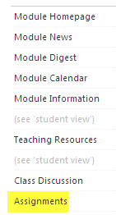

- Click "My StudyNet TurnitIn Portal”

- Then use the link to help you access your Turnitin account. http://www.submit.ac.uk/en_gb/home

(If you already have a Turnitin account, please DO NOT use this feature - it might get confusing if you ended up with two accounts.)

