Turnitin for Postgraduate Dissertations

Only one assignment should be created for students to both ‘Submit draft to Turnitin’ and ‘Submit Assignment’.   
The options are clearly labelled and should not confuse students. See student view on the next page.

Students can submit to Turnitin only if the module leader has opted to switch it on.

To do this, module leaders should

1. Click on the assignment tab on the dissertation home page on StudyNet
2. Click activate Turnitin For Students (see below)

Students must not have direct access to Turnitin as this may conflict with submissions via StudyNet

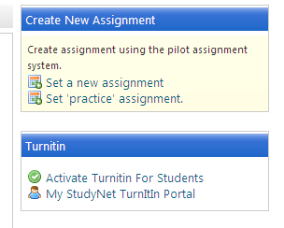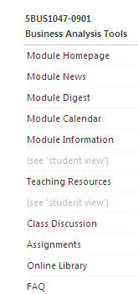

1

2

**Staff View**

3

1. Now create a new assignment by clicking ‘ Set a new assignment’, see 3 above.
2. Complete the assignment details, ensuring that the radio button for ‘**Allow Turnitin Submissions’** is highlighted as ‘Yes ‘

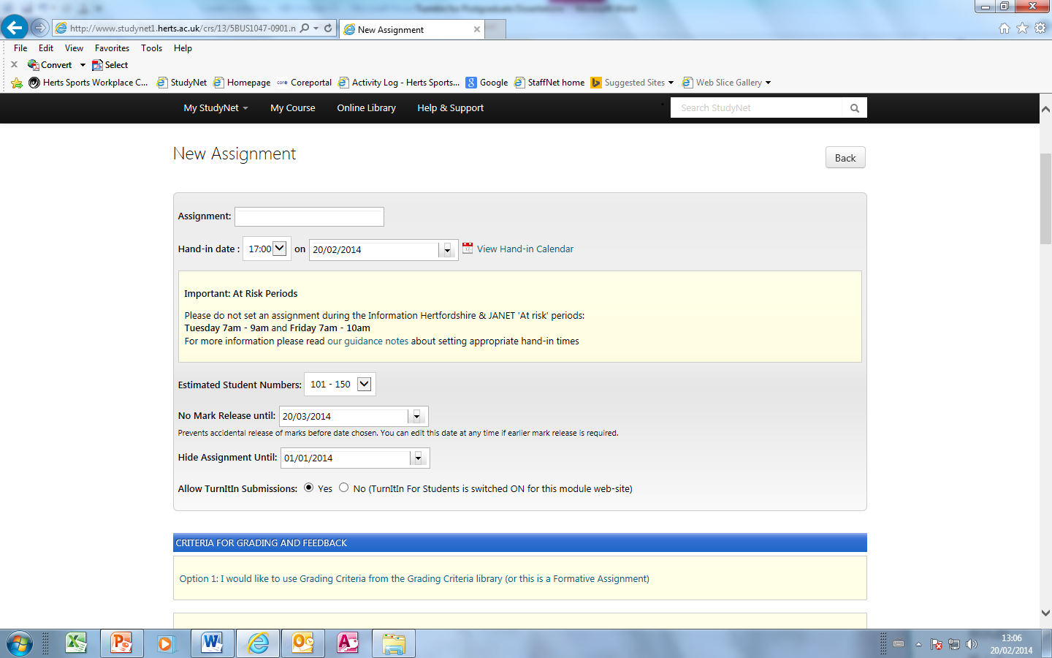

4

1. It would be good practice to include the grading criteria for the dissertation by clicking on option 2 to upload it to StudyNet, but please make sure it is the correct version. Hany Wells will be able to advise you.

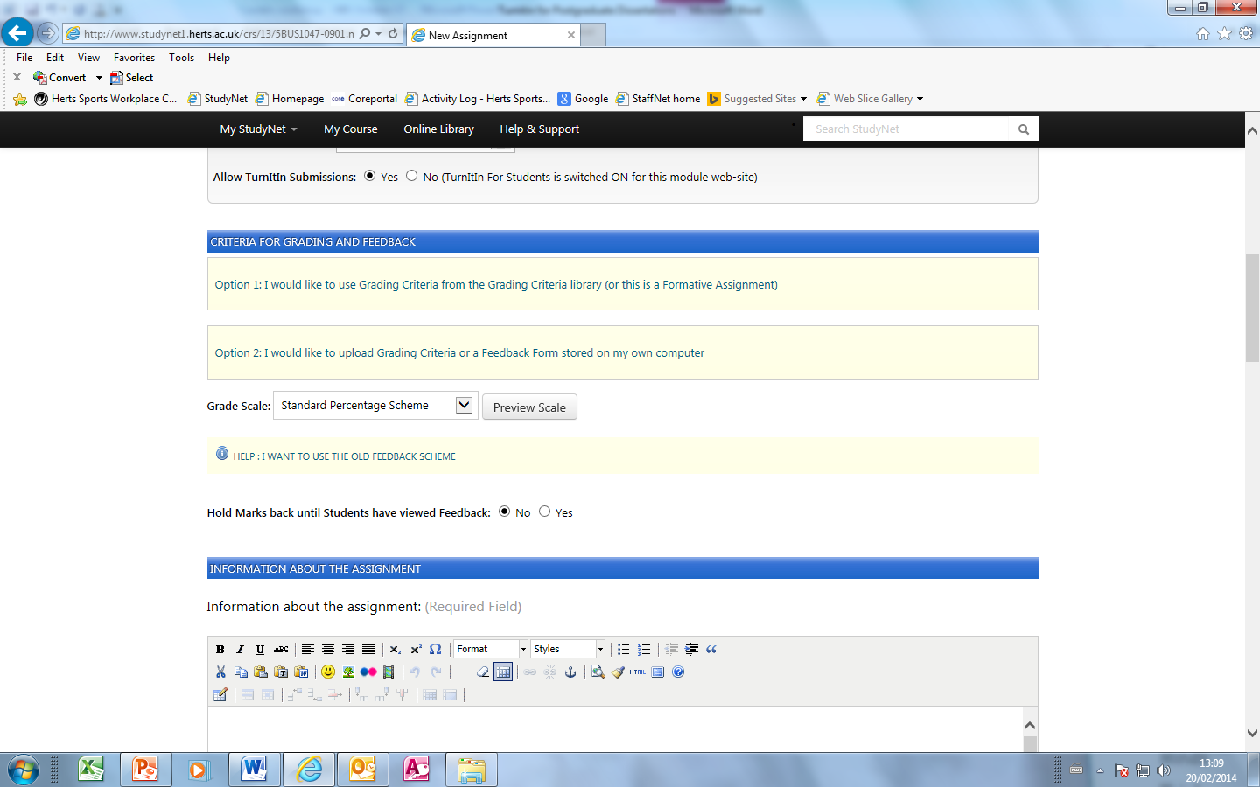

5

**Student View**  
As you can see, there are two buttons clearly labelled, ‘Submit draft to Turnitin’ and ‘Submit Assignment’  
Staff will never be available to view the Turnitin submissions, nor will they be saved in the assignment database. The only submission available to staff is ones that are saved using ‘Submit Assignment’.

**Student View**   
This option is only available prior to the hand-in date/time being reached:

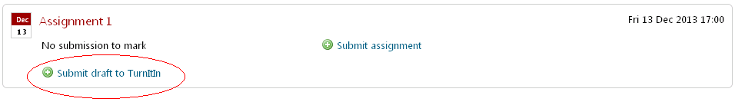

Upon clicking “Submit draft to TurnItIn” students will be presented with a screen that includes the following footer:

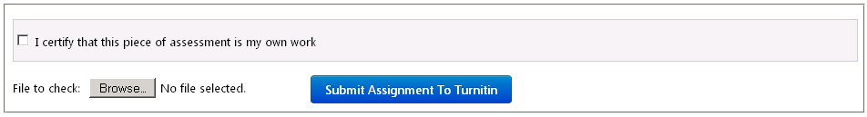





**Staff View**

1. Staff will be able to see who has submitted to StudyNet by clicking on ‘TurnItIn Submissions’

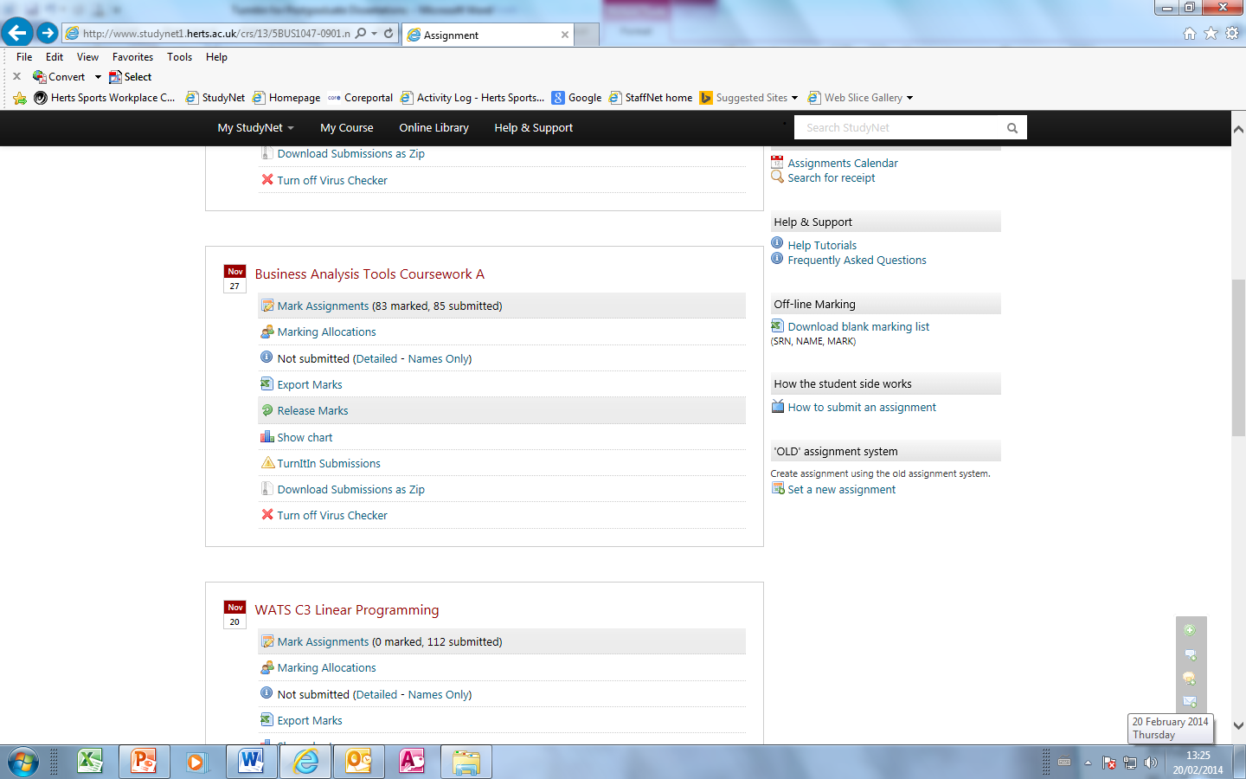

6

1. Below you can see that two students have submitted their work, and by clicking on the green button,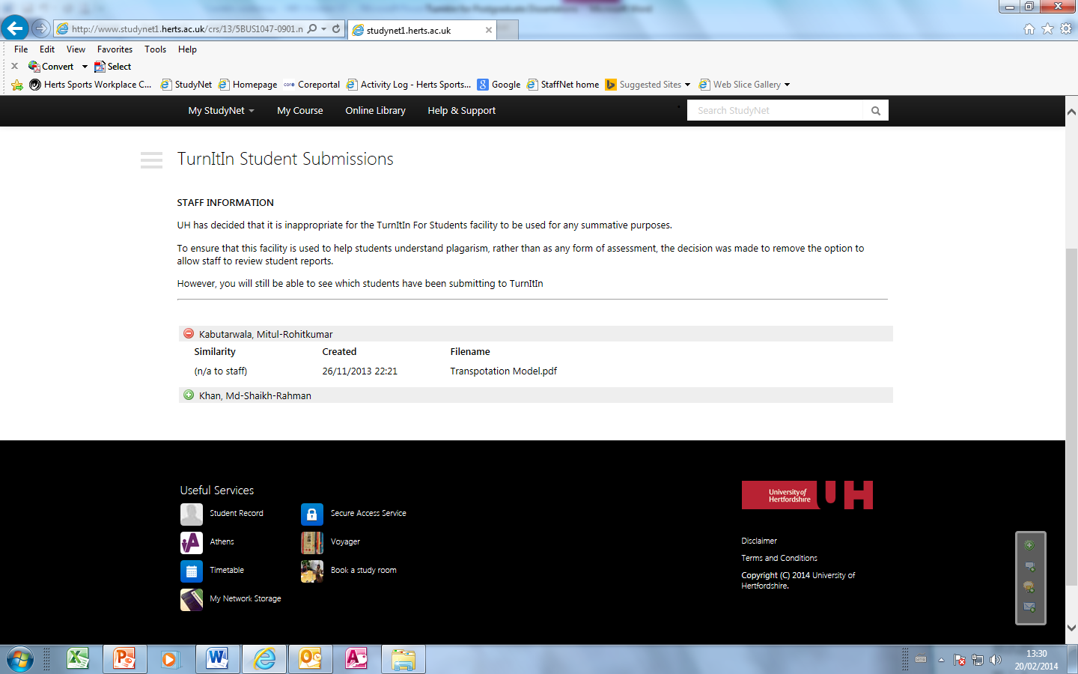  
    it will expand to show the title of the submission .   
    

7

**Downloading a zip file**

1. A zip file can them be downloaded, depending on the size of the zip folder, you may be able to email it to Jenny Evans, who will upload it to Turnitin.



8

1. Once the Turnitin reports have been generated, Jenny will ask you to check the reports for suspected plagiarism.

**Useful links**

Turnitin for Students  
<http://www.studynet2.herts.ac.uk/ptl/common/LIS.nsf/Search/4CE15B256852C58D802577C9003762AD/$FILE/Turnitin+for+Students+Dec+2013+final.pdf>

<http://www.studynet1.herts.ac.uk/ptl/common/LIS.nsf/lis/Turnitin>

Information and Accounts for staff  
<http://www.studynet1.herts.ac.uk/ptl/common/LIS.nsf/lis/TurnitinUK>